**Exercise: Setting up the repository**

**Overview**

In earlier courses in the Front-End Developer program, including [React Basics](https://www.coursera.org/learn/react-basics/home/welcome) and [Advanced React](https://www.coursera.org/learn/advanced-react/home/week/1), you used create-react-app to build your own starter, boilerplate React projects. This means that, by now, you should be quite familiar with setting up a React project using VS Code and the create-react-app npm package. Furthermore, you should also understand version control best practices and be able to track and manage changes to your code. In this exercise and exercises to come, you will integrate this understanding and further expand your skillset, starting with setting up a repository with GitHub.

The following resources may help you complete this exercise:

* [React Basics - Setting up a React project in VS Code](https://www.coursera.org/learn/react-basics/supplement/QjCEc/setting-up-a-react-project-in-vs-code-optional)
* [Version Control - What is version control?](https://www.coursera.org/learn/introduction-to-version-control/lecture/gz0xo/what-is-version-control)
* [Version Control - Create your GitHub account](https://www.coursera.org/learn/introduction-to-version-control/item/0KErG)

**Scenario**

It's time for you to start building the web application for the Little Lemon website. You’ll begin by setting up the project on your local machine and tracking it with Git.

**Instructions**

**Step 1: Setup a new React app using create-react-app**

* Navigate to a folder on your machine where you want Little Lemon restaurant’s web app to live.
* Start a new React project inside the chosen folder using the **npm init react-app my-app** command, where **my-app** is the name of your choice.
* For assistance, refer to the "Opening the built-in VS Code terminal and running **npm init** react-app command" section in the [Setting up a React project in VS Code](https://www.coursera.org/learn/react-basics/supplement/QjCEc/setting-up-a-react-project-in-vs-code-optional) lesson item from the React Basics course.

**Step 2: Add a new repository on GitHub**

* Navigate to your GitHub account.

**Tip:** If you need to create an account, refer to the [Create your GitHub account](https://www.coursera.org/learn/introduction-to-version-control/supplement/AJsQp/create-your-github-account) lesson item.

* Inside the GitHub account, create a new repository.

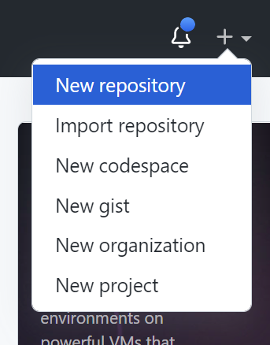

* Once the new repository window displays, note the URL of the repository.

**Step 3: Use the git command to push to your repository**

Once you’ve built the starter app using create-react-app, navigate to the directory using the command line. You will need to push your files to the repository on GitHub.

* Run the **git init** command to initialize the repository.
* Use the **git add** command to stage your files for commit.
* Use the **git commit** command to commit your staged changes.

**Tip:** You may refer to the [Add and commit](https://www.coursera.org/learn/introduction-to-version-control/lecture/UADXz/add-and-commit) lesson item in the Version Control course for further assistance.

* Use the **git remote** command to add a remote for the repository on GitHub.

**Tip:** If you’re unsure of the remote URL, view the repository on GitHub and it will provide you with the relevant information.

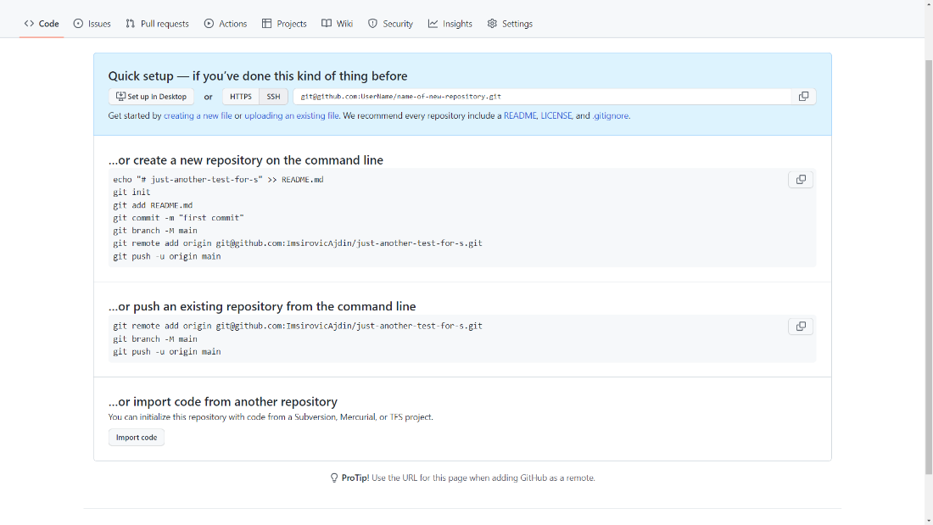

You may find it helpful to revisit the [Connecting to GitHub via HTTPS](https://www.coursera.org/learn/introduction-to-version-control/item/0KErG), [Connecting to GitHub via SSH](https://www.coursera.org/learn/introduction-to-version-control/item/qZwXl) and [Remote vs. local](https://www.coursera.org/learn/introduction-to-version-control/lecture/JtPEE/remote-vs-local) lesson items in the Version Control course for additional guidance.

* Use the **git push** command to push the commits to the remote repository.

**Tip:** Refer to the [Push and pull](https://www.coursera.org/learn/introduction-to-version-control/lecture/N4dUy/push-and-pull) lesson item for further assistance.

* Run the **git status** command, then the **git log** command to confirm that Git is tracking your project locally and that you have the correct Git user set up.
* Log on to GitHub and check that your commits are visible on the repository

**Conclusion**

You have completed all the steps necessary to set up your project's Git. You can now push every new commit to the remote origin and share your project's code with the world.